Report 22.02.24
25mm beam under shear loading
Setup info:
- Labview settings are all the same as were used in previous experiments
- Beam was clamped in position 1 for all tests i.e. 415mm effective beam length
- Loading was applied with weights sitting on hook at beam end
- The strain gauges were calibrated while the hook was sitting on the beam (to zero out strain due to its weight)

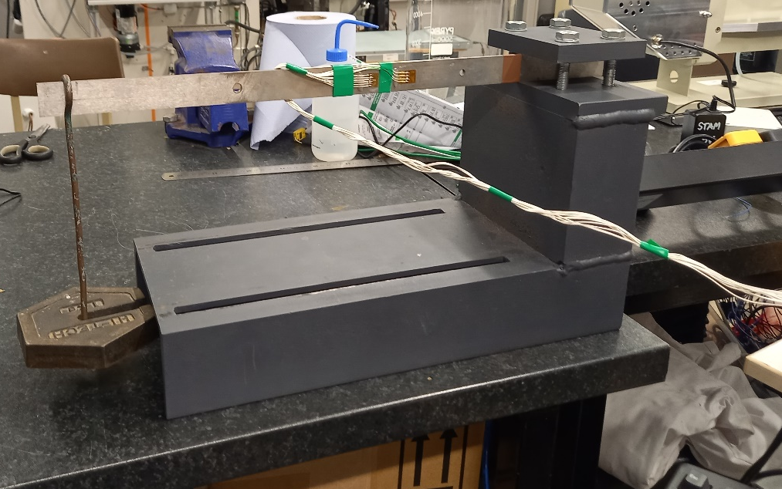
Figure 1. Shear loading setup
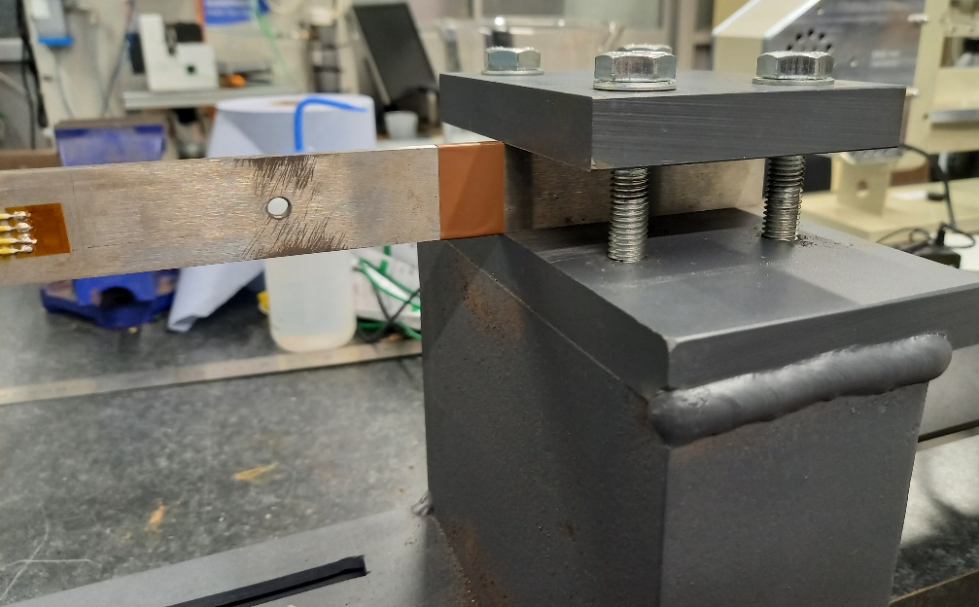
Figure 2. Beam on its side in clamp

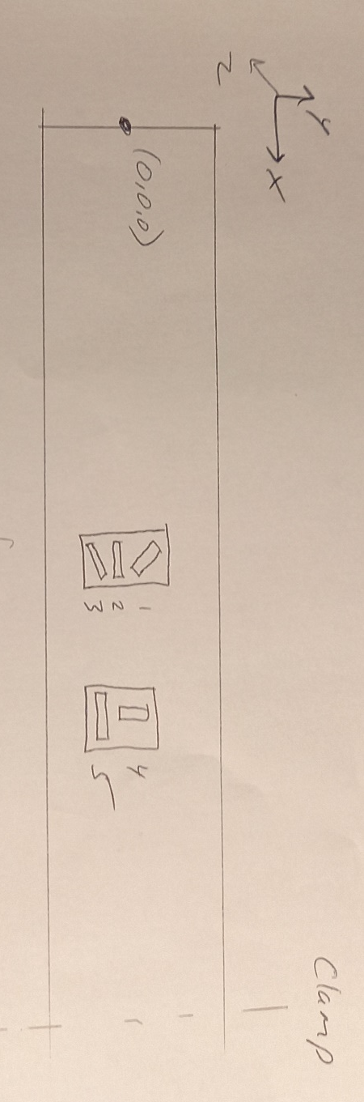
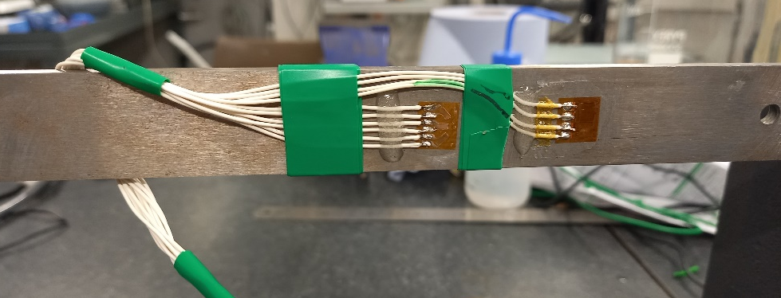
Figure 3. Strain gauges installed on 25mm beam

Figure 4. Rough diagram with strain gauge labelling for 25mm beam

Sensor | X coordinate | Y coordinate | Z coordinate | Axial angle | Gauge Factor | Resistance
1 | 269 | 2.1  (10.4 from top) | 4 | -45 | 2.070 | 120
2 | 269 | -1  (13.5 from top) | 4 | 0 | 2.085 | 120
3 | 269 | -4.7  (17.2 from top) | 4 | 45 | 2.070 | 120
4 | 305 | -1  (11.5 from top) | 4 | 90 | 2.085 | 120
5 | 305 | -4.5  (16 from top) | 4 | 0 | 2.115 | 120

Table 1. Setup information for gauges on 25mm beam

Figure 4. Results for strain guages 1-5 on 25mm beam under shear bending

Figure 5. Strain gauge 1 results under shear bending

Load (Kg) | Load (N) | Gauge 1  (µε) | FEA  (µε) | Difference  (µε) | Difference  (%)
1 | 9.81 | -4.4 | -3.8 | 0.6 | -14%
2 | 19.62 | -4.5 | -7.7 | -3.2 | 70%
3 | 29.43 | -4.5 | -11.5 | -7.0 | 154%
5 | 49.05 | -8.2 | -19.2 | -11.0 | 133%
6 | 58.86 | -9.9 | -23.0 | -13.1 | 133%
8 | 78.48 | -12.3 | -30.7 | -18.4 | 150%
10 | 98.1 | -12.5 | -38.4 | -25.9 | 207%
12 | 117.72 | -17.7 | -46.1 | -28.4 | 160%

Table 2. Comparison of predicted and actual results for strain gauge 1

Figure 6. Strain gauge 2 results under shear bending

Load (Kg) | Load (N) | Gauge 2  (µε) | FEA  (µε) | Difference  (µε) | Difference  (%)
1 | 9.81 | -5.1 | 2.3 | 7.4 | -145%
2 | 19.62 | -4.4 | 4.6 | 8.9 | -204%
3 | 29.43 | -2.9 | 6.8 | 9.8 | -333%
5 | 49.05 | -8.8 | 11.4 | 20.2 | -230%
6 | 58.86 | 29.1 | 13.7 | -15.4 | -53%
8 | 78.48 | 50.5 | 18.2 | -32.3 | -64%
10 | 98.1 | 48.9 | 22.8 | -26.1 | -53%
12 | 117.72 | 8.9 | 27.4 | 18.4 | 206%

Table 3. Comparison of predicted and actual results for strain gauge 2

Figure 7. Strain gauge 3 results under shear bending

Load (Kg) | Load (N) | Gauge 3  (µε) | FEA  (µε) | Difference  (µε) | Difference  (%)
1 | 9.81 | -3.3 | -5.2 | -1.9 | 58%
2 | 19.62 | -3.0 | -10.4 | -7.4 | 243%
3 | 29.43 | 0.1 | -15.6 | -15.7 | -13249%
5 | 49.05 | -3.2 | -26.0 | -22.7 | 704%
6 | 58.86 | 9.3 | -31.1 | -40.4 | -436%
8 | 78.48 | 4.4 | -41.5 | -45.9 | -1048%
10 | 98.1 | -2.4 | -51.9 | -49.5 | 2046%
12 | 117.72 | -18.5 | -62.3 | -43.8 | 237%

Figure 8. Strain gauge 4 results under shear bending

Load (Kg) | Load (N) | Gauge 4  (µε) | FEA  (µε) | Difference  (µε) | Difference  (%)
1 | 9.81 | 3.1 | -1.1 | -4.2 | -136%
2 | 19.62 | 1.5 | -2.2 | -3.7 | -252%
3 | 29.43 | 0.6 | -3.4 | -3.9 | -695%
5 | 49.05 | 2.2 | -5.6 | -7.8 | -359%
6 | 58.86 | -27.6 | -6.7 | 20.9 | -76%
8 | 78.48 | -59.0 | -9.0 | 50.0 | -85%
10 | 98.1 | -65.0 | -11.2 | 53.8 | -83%
12 | 117.72 | -34.3 | -13.4 | 20.8 | -61%

Table 4. Comparison of predicted and actual results for strain gauge 4

Figure 9. Strain gauge 5 results under shear bending

Load (Kg) | Load (N) | Gauge 5  (µε) | FEA  (µε) | Difference  (µε) | Difference  (%)
1 | 9.81 | -4.1 | -7.5 | -3.5 | 85%
2 | 19.62 | -11.5 | -15.0 | -3.6 | 31%
3 | 29.43 | -9.0 | -22.6 | -13.5 | 150%
5 | 49.05 | -24.4 | -37.6 | -13.2 | 54%
6 | 58.86 | -19.0 | -45.1 | -26.1 | 138%
8 | 78.48 | -41.2 | -60.2 | -19.0 | 46%
10 | 98.1 | -57.9 | -75.2 | -17.3 | 30%
12 | 117.72 | -74.4 | -90.2 | -15.9 | 21%

Table 5. Comparison of predicted and actual results for strain gauge 5

Conclusions
The experimental results didn't agree with FEA predictions. The model predicted a linear increase in strain as more weight was added but this trend was only demonstrated by the axial gauges (2 and 5 below). Even then, the relationship isn't perfectly linear and the predicted/actual strains differ significantly.
The non-linear changes in strain as weight is applied seem to indicate that the primary strain direction is constantly changing for gauges 1,3 and 4. The FEA does not predict this behaviour. Perhaps the FEA software is incapable of properly capturing the strain response under shear bending? Nope- later found out that is’t due to bending in an unexpected direction- investigated in Thesis Ch 5 Section 5.5.

